TASK 2:

* Create a Windows Virtual Machine.
* Install the IIS service on it.
* Make the website publicly accessible.

**Learning:**

**IIS Service:** Internet Information Services server (IIS server) is a Windows Server-based web application used to deliver website content over the internet to an end user.

Steps to create VM and then install IIS service on it and make it publicly accessible:

Step1: Open Virtual Machine Service inside Azure Portal and fill all details regarding VM and then click on Create. After this, your VM will pe deployed.

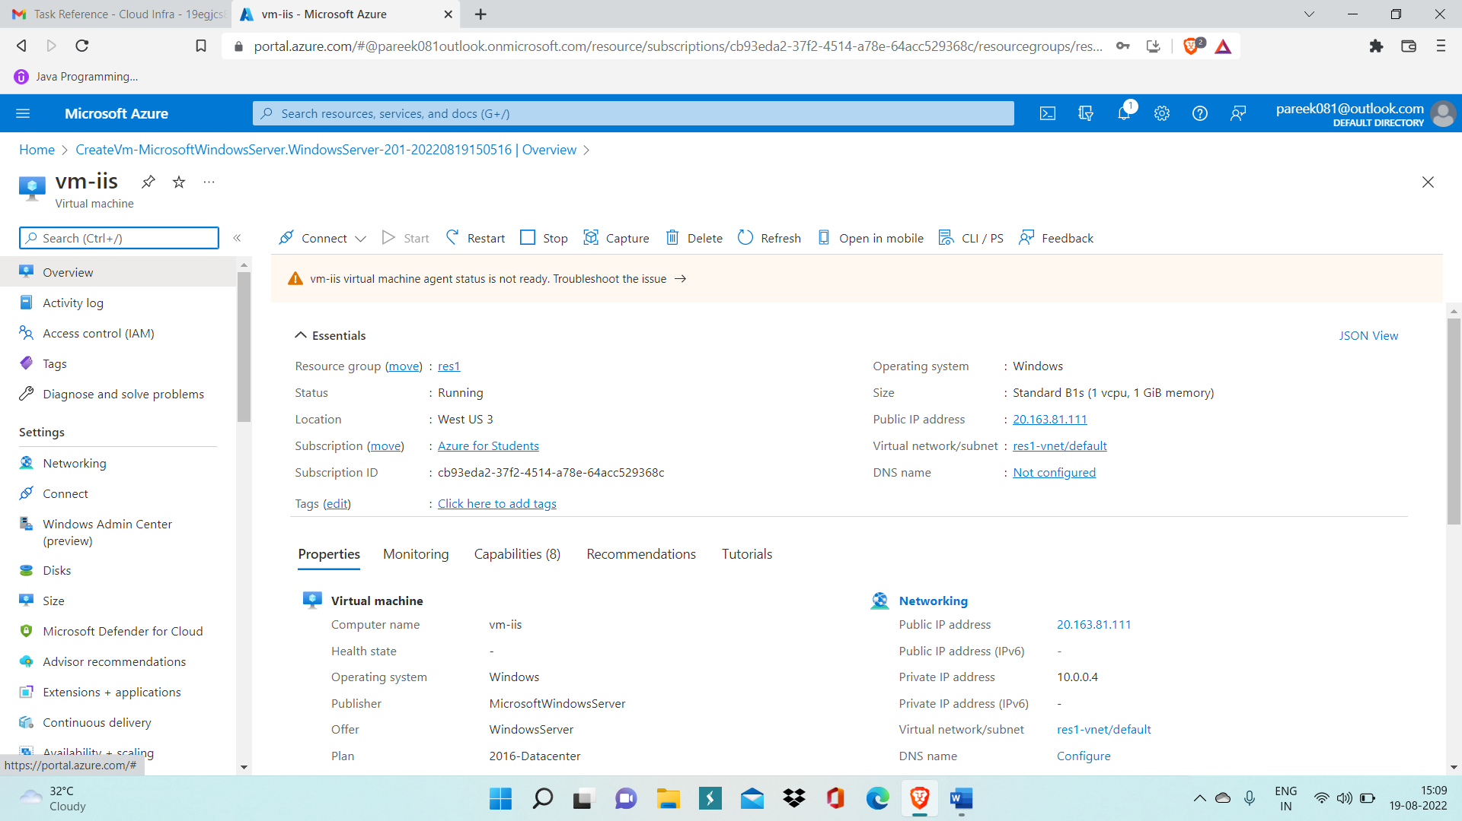

Step 2: Now, download RDP file and enter all authentication details.

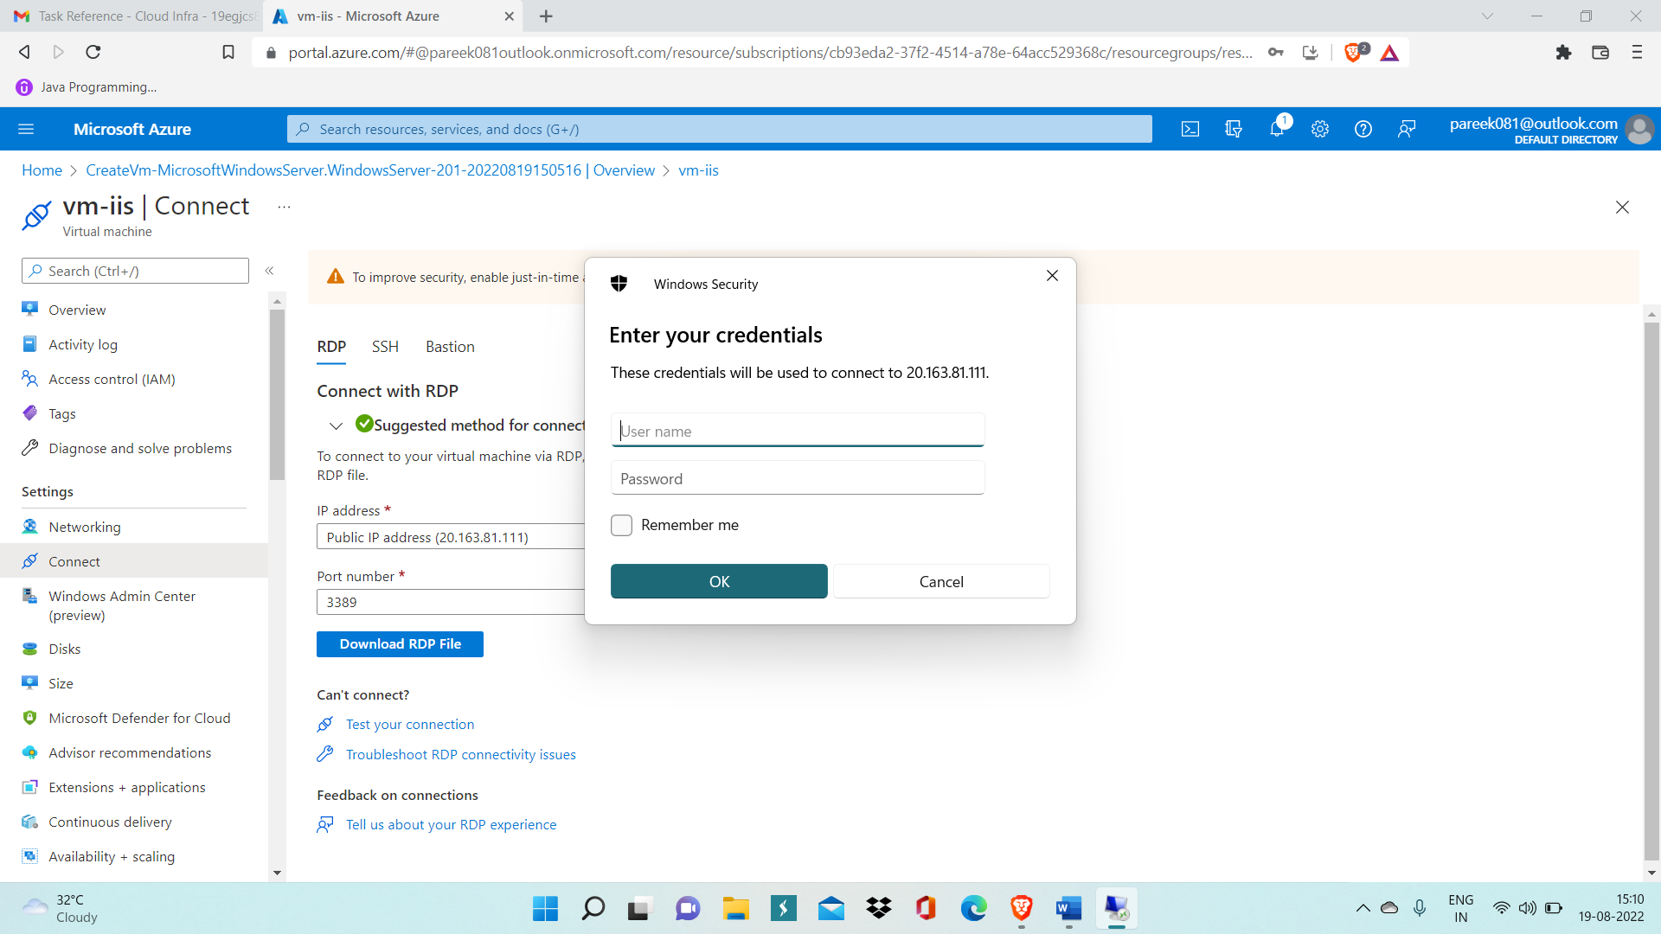

Step 3: Now after VM gets opened, Open Server Manager by searching it in search tab.

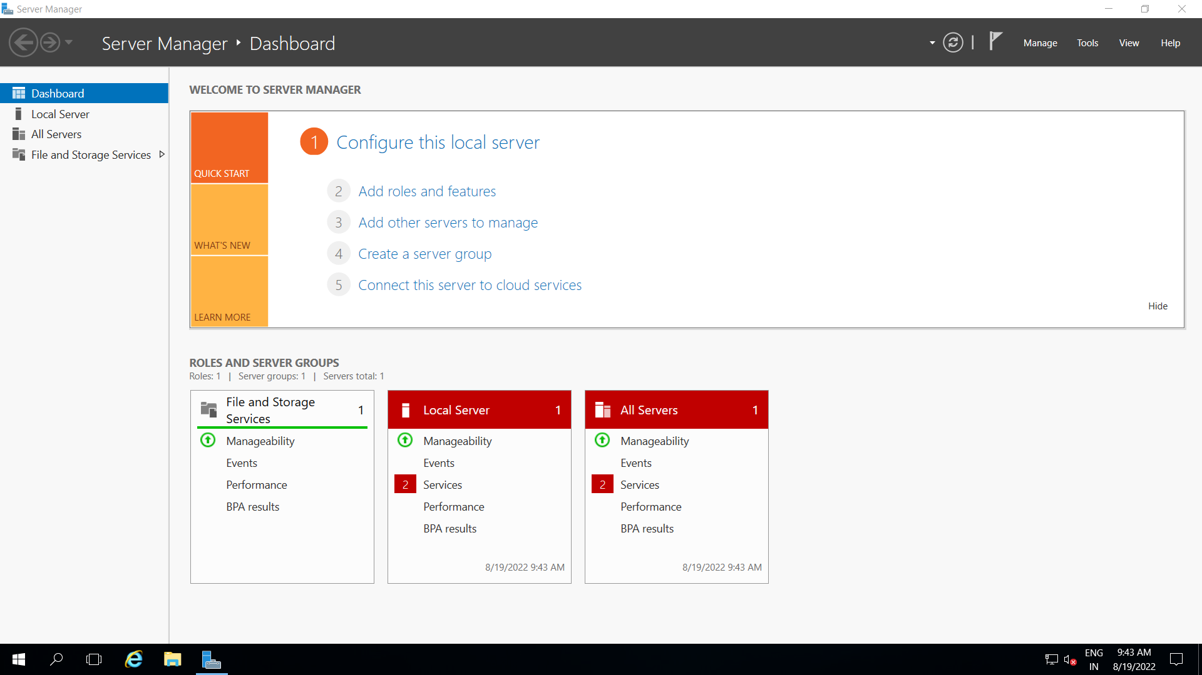

Step 4: Now click on Add roles and features, then Add roles and fetures wizard will get opened.

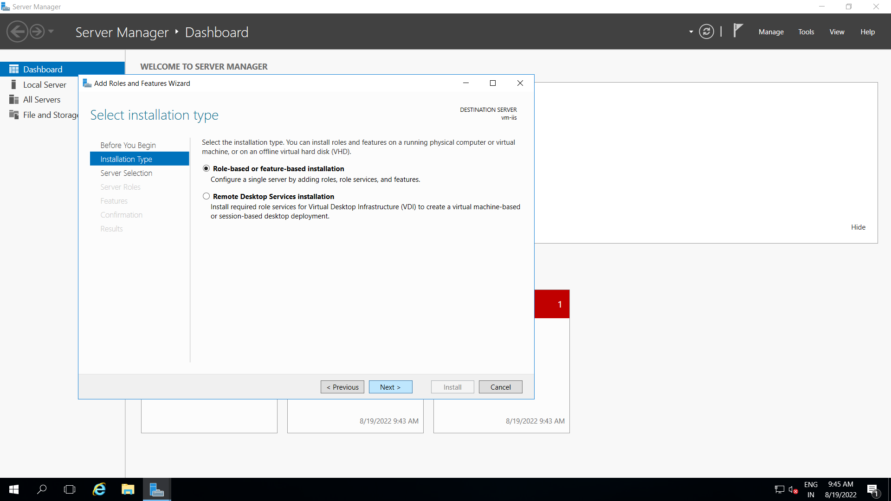

Step 5: Now, select Web Server (IIS) service inside Server roles and install it.

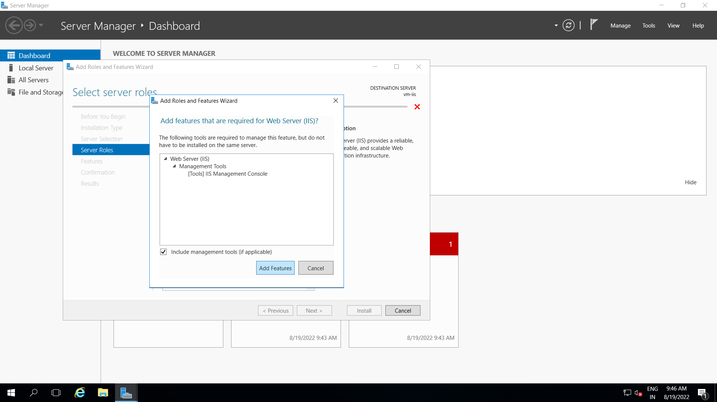

Step 6: After installation of IIS service is done, go to Networking interface of your VM.

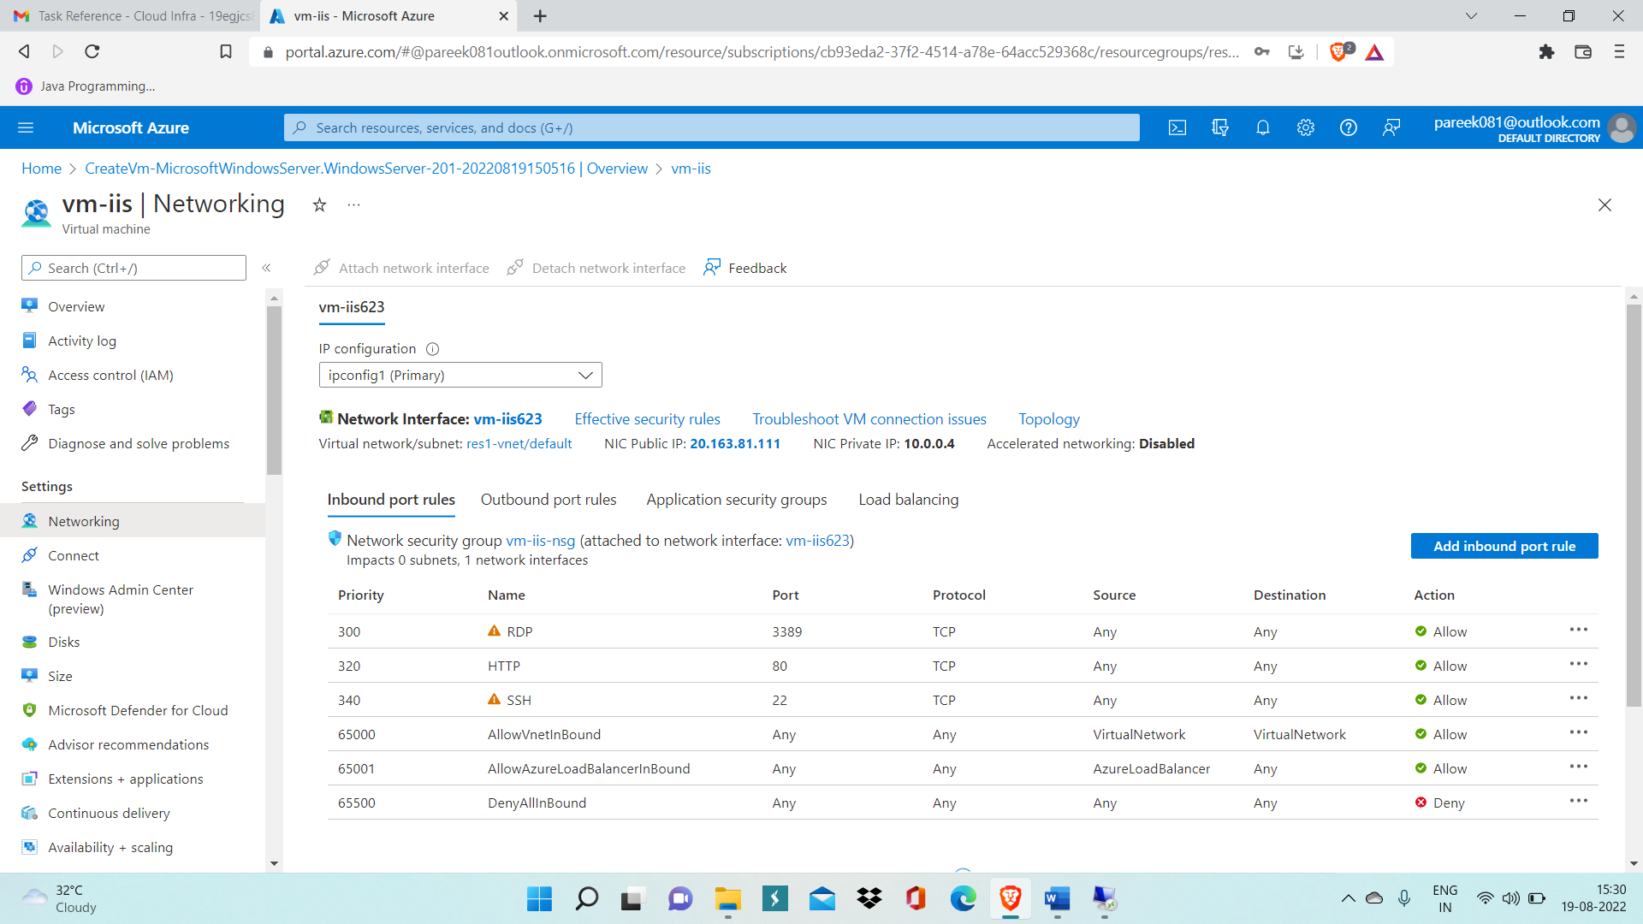

Step 7: Click on Add Inbound Port Rules and Click on HTTP inside custom dropdown menu and then click on ADD.

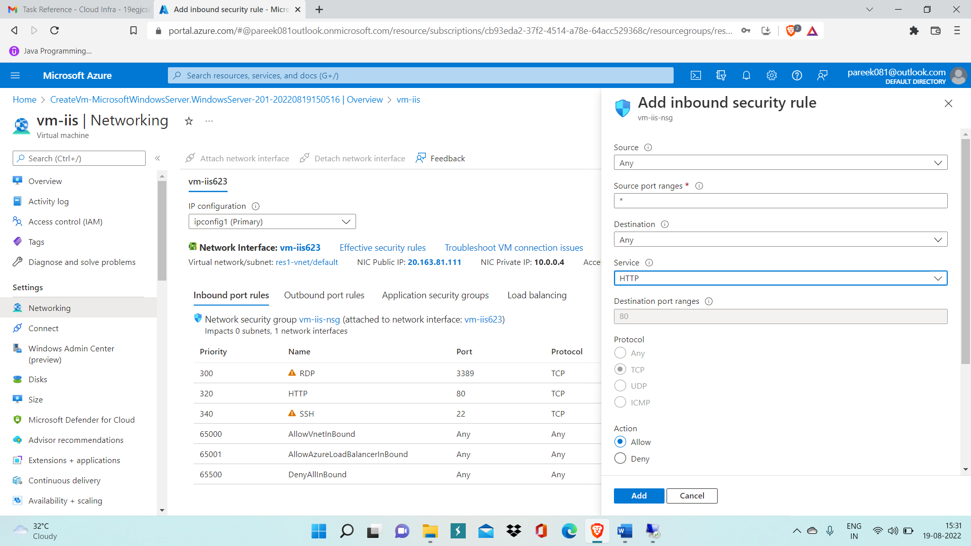

Step 8: Now, your website is publicly accessible and you can easily access it by copying the public IP address of your VM and pasting it on browser search tab.

For eg: Here in below fig. public IP pasted on web browser is 20.163.81.111

